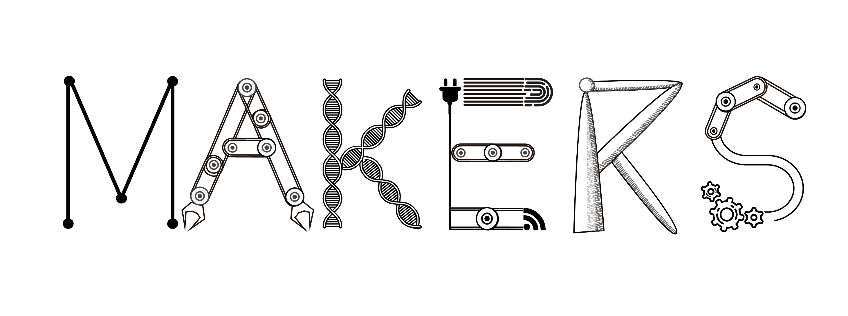

Disruptive Industry 4.0

David Bailey (Aston Business School, Birmingham UK)

Lisa De Propris (Birmingham Business School, UK)

Abstract

The objective of this concept paper is to present a systematic and critical overview of the literature often captured by the overarching label of ‘Industry 4.0’. Although concerns have been raised with respect to its explanatory power of the implications of the technological change underway, Industry 4.0 as a term is now widely used.

Our analysis starts with a critical overview of the dynamics of technological change: it starts with Kondratiev waves leading to the more recent conceptualisation of a ‘techno-economic paradigm’ (Perez, 2010). The debate on the current wave of technological change is reviewed leading to a critical assessment of the wide ranging definitions of Industry 4.0 emerging from the academic and policy debates. The core argument developed in the paper is that the current understanding of Industry 4.0 is far too narrow and reductive to fully capture the fundamental disruption that the new technologies can unleash. The 4th industrial revolution ((Marsh, 2015; Rifkin, 2016) will create a new cyber-physical space of production, the so-called smart factory, that will be digitally enabled to connect with other such spaces along the supply chain. This creates digital and ‘smart networks of machines’ (Deloitte, 2015).

We propose a broader definition of Industry 4.0 that unpacked the scale and the breadth of the changes in production, consumption and innovation. We discuss where value is created in the new manufacturing model we propose, and the importance of understanding the difference between technology and sector. We present some pinch points in embracing and developing Industry 4.0 and what role policy must have to release such holdups.